User Manual on
Mongo DB
Part- 2

Document Revision and Approval History

Title: User Manual on Couch DB

ID :

Effective: 03-Jun-2014
Edition No. | Release Date | Author’s Name | Software Version | Reason for Change / Description of Changes
1 | 06/06/2014 | Praneeth | Mongo 2.6.4
2 | 05/10/2014 | Praneeth | Mongo 2.6.4
3 | 03/11/2014 | Praneeth | Mongo 2.6.4
4 | 01/06/2015 | Harish | Mongo 2.6.4

About:
This tutorial is intended to provide you hands-on understanding of working with time series data stored in MongoDB, executing queries and map reduce programs for solving the challenge that Best Cold Chain faces.

Table of Contents

- Objective
- Complete End-End IOT Flow diagram
- Practical flow diagram
- Map Reduce introduction
- Map Reduce on MongoDB
- Exercise on Mapreduce
- MapReduce Example 1 - Get count of trips where material is fish
- MapReduce Example 2 - Get list of all trips where material was fish
- MapReduce Example 3 - Get all trips that were in progress during a time period
- MapReduce Example 4 - Get all trips for fish where material was spoilt in a particular month. Solve the business problem for Best Cold Chain

- Objective:
- Hands-on experience on Map Reduce
- How to solve business problems using Map Reduce and the IoT data gathered from the device

- Complete End-End IOT Flow diagram:

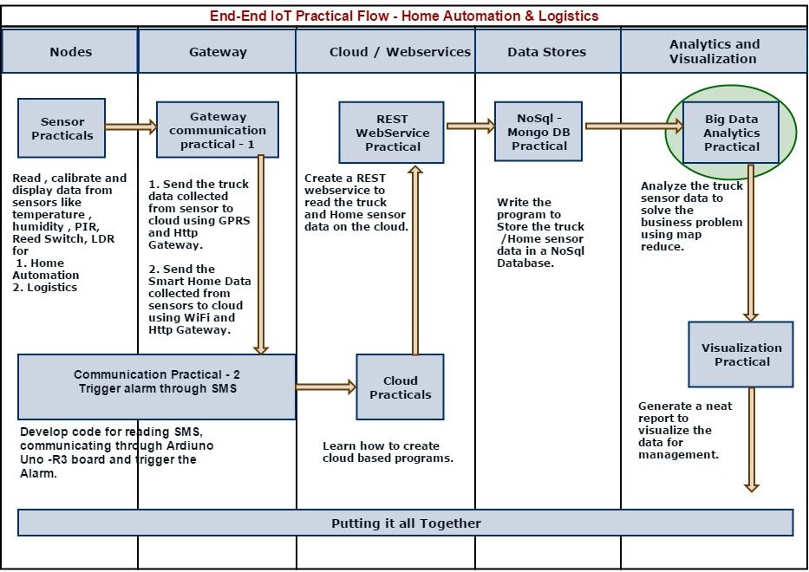

- Practical Flow Diagram:

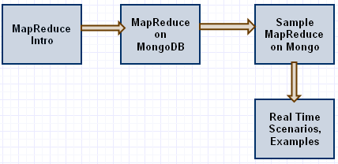

- MapReduce Introduction:
- A map function, processes documents from your dataset into key-value pairs as an output.
- A reduce function, combines the set returned by map and performs aggregation on it
  - Reduce function is passed a set of intermediate values and combines them to a single value
  - Reduce functions must accept, as input, results emitted by its corresponding map function as well as results returned by the reduce function itself.

Explanation:
- In very simple terms, the mapReduce command takes 2 primary inputs, the mapper function and the reducer function.
- A Mapper will start off by reading a collection of data and building a Map with only the required fields we wish to process and group them into one array based on the key. And then this key value pair is fed into a Reducer, which will process the values.

Ex: Let’s say that we have the following data, Sample data from DB
[
{
device: ABC123,
Temperature: 26
},
{
device: ABC123,
Temperature: 27
},
{
device: XYZ123,
Temperature: 28
},
{
device: ABC789,
Temperature: 23
},
{
device: ABC789,
Temperature: 22
}
]

- And we want to count the price for all the items with same name. We will run this data through a Mapper and then a Reducer to achieve the result.

When we ask a Mapper to process the above data without any conditions, it will generate the following result
Key Value
ABC123 [26,27]
XYZ123 [28]
ABC789 [23,22]

It has grouped all the data together that has similar key, in our case a name. Then these results will be sent to the Reducer

- Now, in the reducer, we get the first row from the above table. We will iterate through all the values and average them. Next, the reducer will receive the second and it will do the same thing, till all the rows are completed.

The final output from reducer will be
Name Total
ABC123 26.5
XYZ123 28
ABC789 22.5

- We now understand why a Mapper is called a Mapper (because, it will create a map of data) & why a Reducer is called a Reducer (because it will reduce the data that the mapper has generated to an aggregated output).

- MapReduce on MongoDB:

- To perform map-reduce operations, MongoDB provides the mapReduce command, in the mongo shell and db.collection.mapReduce() wrapper method in java

Syntax:
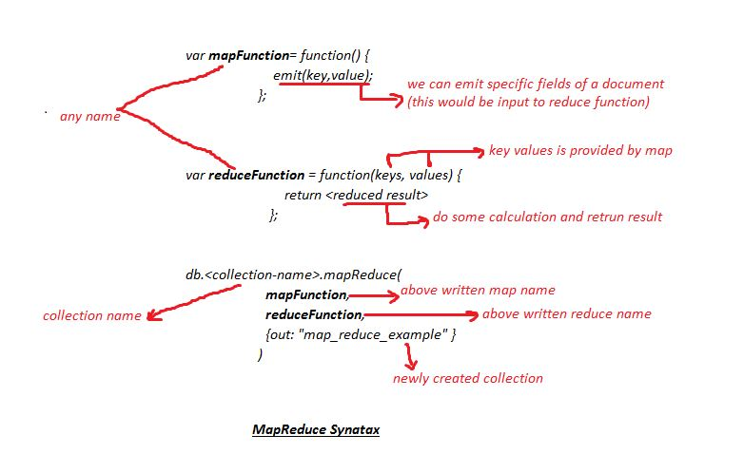

- Exercise on MapReduce:

- Open command prompt and run mongo command to connect to the server. By default you will be in C:\Users\Participants directory. Check the below screen for reference

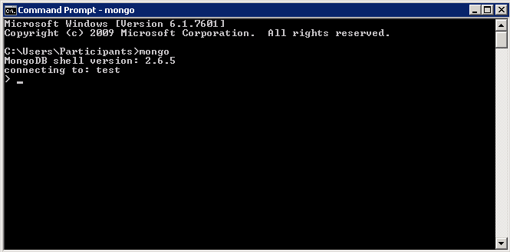
Screen 1

- Then write below command
Command: use bcc
This makes the current database as "bcc". All our documents are stored in this database

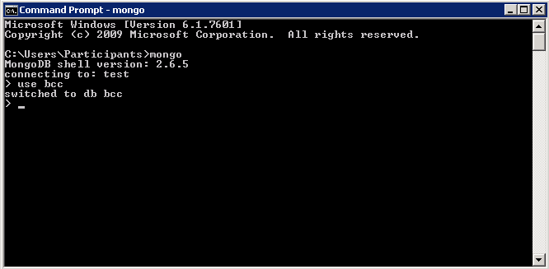
Screen 2

- MapReduce Example 1:
Requirement: Get count of trips where material was fish
MapReduce:
Code Snippet 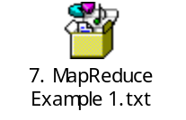

var mapFunction1= function(){
if(this.material == 'Fish')
{
emit(this.material,this)
}
}
var reduceFunction1= function(keys,values){
return values.length;
}
db.trips.mapReduce(
mapFunction1,
reduceFunction1,
{ out: "map_reduce1" } )

Run above map reduce code in mongo shell, as shown in below screen shot

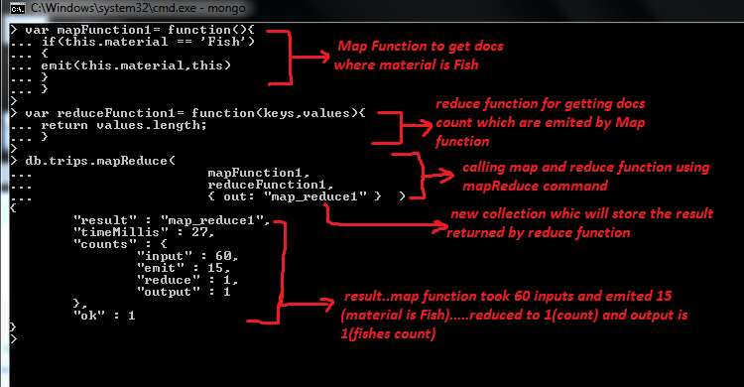
This will create a new collection map_reduce1 to store the results from the map reduce that we have executed.

To check the result, run below command on mongo shell
db.map_reduce1.find()
For reference check below screen shot

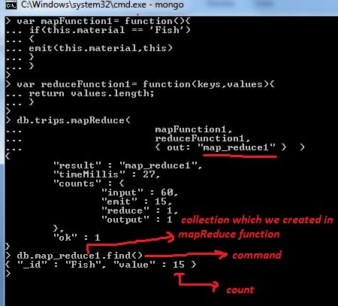

Explanation:
Mapper:
var mapFunction1 = function(){
if (this.material == 'Fish')
{
emit(this.material, this)
}
}

- In the above function, this refers to the document that the map-reduce operation is processing.
- We can call particular filed from the document by using its name, here we are accessing single field that is this.material
- Emit is for emitting the result to the reduce, it takes two parameter key and value.
- In above code we are emitting this.material as the key and this (for accessing all fields of the document) as the value.

Reducer:

var reduceFunction1 = function(keys, values){
return values. length;
}
- Here reduce function is taking result emitted by map function.
- Second parameter of reduce function contains list of docs as array where material is fish.
- values.length will return the count of fishes

MapReduce :

db.trips.mapReduce(
mapFunction1,
reduceFunction1,
{out: "map_reduce1" }
)

- After writing mapper and reducer then we have to call mapReduce command on collection by passing mapper and reducer names followed by new collection name.
- In above code
trips → collection name
mapFunction1 → mapper name
reduceFunction1 → reducer name
map_reduce1 → new collection which will hold the result

- MapReduce Example 2:

Requirement: Get list of all trips where material was fish. In the previous example we saw how to get the count of trips where material was fish. Here we get a list of those trips.

MapReduce:
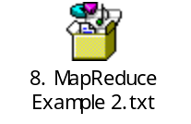

var mapFunction2= function(){
//
if(this.material == 'Fish')
{
emit(this._id,this)
}
}
var reduceFunction2= function(keys,values){
}
db.trips.mapReduce(
mapFunction2,
reduceFunction2,
{ out: "map_reduce2" } )

To check result, run below command on console.
db.map_reduce2.find().pretty()
// pretty() helps format the output

As you would have observed, we are not doing any aggregation. Therefore, the reduce function above is empty

- MapReduce Example 3:

Requirement: Get all trips that happened during a time period. This will help to get our target trips that we need to assess to detect material damage

MapReduce:
- Here we combine trip and transactions collections as single collection because time stamp is available in transactions and other related information for transaction is available in trips.

Code for creating new collection by combining trips and transactions

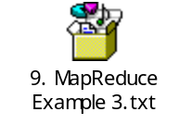

db.transactions.find({ trip_id: { $exists: true } }).forEach(function (x) {
db.trips.find({"_id":x.trip_id},{_id:0}).forEach(function (y) {
var keys = Object.keys(y);
for(var i=0;i<keys.length;i++){
x[keys[i]] = y[keys[i]];
}
});
db.trip_trans.save(x);
})
- trip_trans is the new collection which is holding trip and transactions collections data

var mapFunction3 = function(){
//getting timestamp from database
var timestamp = this.timestamp*1000;
//taking start time stamp
var st = new Date("Jan 02, 2014 09:15:00").getTime();
//taking end time stamp
var et = new Date("Jan 02, 2014 10:15:00"). getTime ();
//timestamp should be in between start and end time stamps,
//And material is Fish
if(this.material == 'Fish' && (timestamp >= st && timestamp <=et) )
{
emit(this._id, this);
}
}

var reduceFunction3 = function(ids, values){}
//calling mapReduce command on trip_trans collection
//here map_reduce3 will be new collection
db.trip_trans.mapReduce(
mapFunction3,
reduceFunction3,
{ out: "map_reduce3" } )

To check result, run below command on console.
db.map_reduce3.find().pretty()

- MapReduce Example 4:

Requirement:

Best cold chain is facing huge claims for delivery of spoilt Fish. Below is the number of claims received in last 10 weeks. Get all trips for fish where material was spoilt in a particular month

Customer Name | Complaints count
Setu Madhav | 20
Aska sea | 24
Sea Food Express | 24
Al Saad | 18
Astra | 22
Hiran | 28

Axelta has installed devices on vehicles, these devices sends the data to the Axleta Platform.
The task is to create a map reduces on the fleet data to analyze the information and check whether the claims are genuine or not.

Domain Assumption:
If the temperature in the refrigerated van goes out of the prescribed range for more than
3 consecutive times the material would have got damaged

MapReduce: Create map, reduce and then execute it separately

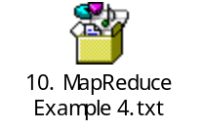
var mapFun4 = function(){
//getting timestamp from data base
//And converting it to milliSeconds
var timestamp = this.timestamp*1000;
var min_temp, max_temp, temp;
//getting temperature from database
temp = this.temperature;
//getting max and min temperatures from database
max_temp = this.maximum_temperature;
min_temp = this.minimum_temperature;
//taking start and end dates
var st = new Date("2014,01,01").getTime();
var et = new Date("2014,01,31"). getTime();
if(this.material == 'Fish' && (temp < min_temp || temp > max_temp) && (timestamp>=st && timestamp<=et))
{
emit(this.trip_id, this);
}
}

var reduceFun4 = function(k, v){
var json1 = {};
var counter = 0;
var previousTimestamp;

for(var i=0; i < v.length; i++){
if (counter == 0) {
previousTimestamp = v[i].timestamp;
counter++;
continue;
}
if (counter = 3){
// material already got spoiled
json1.device_no = v[i].device_no;
json1.node_no = v[i].node_no;
break;
}
if ((v[i].timestamp - previousTimestamp)/60 < 16) {
// consecutive temp out of range
counter++
previousTimestamp = v[i].timestamp;
} else {
// not a consecutive error so lets reset the counter
counter = 0;
previousTimestamp = v[i].timestamp;
}
}
if (counter == 3){
// this trip had an issue so lets emit this document
return json1;
}
return null;
}

//calling mapReduce command on trip_trans collection
db.trip_trans.mapReduce(
mapFun4,
reduceFun4,
{
out:{inline:1}
}
)

Output from this will give us the trips where the material would have got damaged. We can analyze this and get our final result to check against the actual claims that the respective customer lodged.

